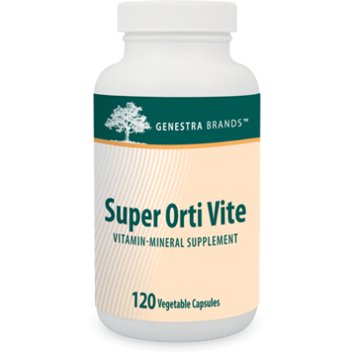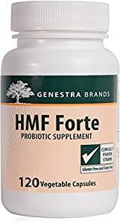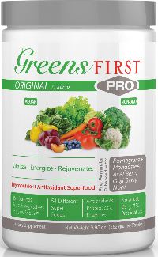

**Super Orti Vite is a broad-spectrum, hypoallergenic formula containing an excellent proportion of vitamins, minerals, bioflavonoids, digestive enzymes, lipotropic factors and antioxidants needed to support health.**

**January Detox Specials**

**HMF Forte promotes optimal intestinal health in children, adolescents, and adults. A healthy gut provides a great route to detox and boost immunity**

**Nourish, rebalance & rejuvenate your body and your health with a daily serving of the organic goodness in Greens First!**