Excellence In Health
Your trusted source for the best in Health & Wellness
from Dr. John Zielonka and Health & Wellness Canada

National Health Day
Founded 17 years ago and where are we today? Not where we should be and
especially so after the past year

© Dr. John Zielonka 2021
…
If you regularly read the newspaper (or watch television or follow the internet) you may have seen the following headline:
National Health Day
Health and Wellness Expert Dr. John Zielonka Declares National Health Day
in Canada - Mayor of Ottawa proclaims it for Nation’s Capital

It has now been 17 years since I first spearheaded this movement in Canada. Initially it was designed to finally accomplish what many Canadians had been asking for over the last 2 decades; an extra holiday between New Year’s and Easter over our long winter. Instead of waiting for the continual debate on who to name the holiday after, I did something unique in government circles – I took action. Since we wanted it for our health, let’s call it what it is, hence, National Health Day was born.
Each year I write letters to every Member of Parliament including the Prime Minister and Minister of Health. I have made numerous television appearances as well as nation-wide newspaper and radio coverage. I also wrote to Ontario Premier Dalton McGuinty 2 years after its inception with the idea and while he turned me down at that time, I was both surprised and pleased to see that “Family Day” suddenly appeared the very next year (although it fails to apply to all Canadians). And for 17 years now, it has been proclaimed each and every year by the Mayor of Ottawa. This year it is on Monday February 15, 2021.

What is National Health Day really all about?
It’s very simple and it really wasn’t about an extra holiday. As much as Canadians claim to be health conscious, the truth is that the majority of the public, the majority of health professionals and the vast majority of politicians don’t even know what the word health actually means. Please appreciate that I’m not talking about serious genetic problems or severely under-privileged people who deserve much better. I’m speaking of the majority of industrialized nations who have the means and ability to be far healthier than they are. If you disagree, then explain our “health care system”. I’m certainly not the first to say that it really is a sick care system that attempts to manage disease. One simply needs to look at demographics to realize that such a system is doomed to failure. There is of course a dictionary definition to the word health.

Health – “the optimal state of physical, mental and social well-being
and not merely the absence of disease or infirmity”

… page 1 of 2
It is necessary to understand that there are 3 key points to this definition;

1. The definition doesn’t just tell you what health is, it also tells you what health isn’t. The fact that you don’t have a disease or that you’re not sick or not in pain does not mean that you’re healthy. I know of no other word in the English language that is defined in this manner. It would be like defining an apple as a fruit that is not a banana.

2. It is a completely holistic approach (physical, mental and social well-being – I would even add spiritual).

3. By its definition health is “optimal”. Therefore, there is really no such thing as being “fairly healthy” or having “average” health. In fact, using the phrase “optimum health” is actually being redundant.

Hence, on National Health Day all Canadians need to do two simple things. One, learn the actual definition of the word health and two; Canadians are encouraged to do anything healthy on this day (although they should obviously practice health every day of their lives).

So, what have we learned 17 years later and especially after last year? Not much.

- We still very much live in a reactive sick-care system and don’t even realize that prevention is not the same as optimal health. We’re really not learning from our mistakes – we’re just learning how to recognize them faster the second time around.

- We rank 30th in the world for health (can you name the 29 other countries ahead of us?) where the average Canadian will spend the last 10 years of their life in sickness, pain and disease. What kind of a life is that to look forward to?

- Canadians are still failing to realize that each person is ultimately responsible for their own health and should make it a priority for the rest of their life. Even without the day off we need to understand that our entire system still misses the mark on health and it’s up to us to change that. To continue to wait for the government to take quick action on our health is really an oxymoron.

If ever there were a time to transform and protect your health for life, now is that time. I urge all Canadians to take action. If all Canadians, especially politicians and doctors understood what the word actually meant, and more importantly acted on it, our country would be a much better place.

Please watch the video here: https://vimeo.com/507291269

Dr. John Zielonka is one of Canada’s most trusted health and wellness experts. He is the Director of Health & Wellness Canada and the Founder of National Health Day in Canada. Both a best-selling author and speaker, he has helped thousands achieve a better way of life. He is a functional health doctor, a 15-time award winning neuro-functional chiropractor, an orthomolecular nutritionist and holds a Fellowship in Vitamins and Anti-Aging. He has made over 100 television and media appearances to help the community and beyond understand what true health is all about. He is owner of the Ottawa Chiropractic & Natural Health Centre, “Ottawa’s Premier Centre for Health & Wellness since 1995” in the World Exchange Plaza in downtown Ottawa. If we can be of service, please call us today at (613) 688-1036, email us at patientadmin@excellenceinhealth.com or visit www.excellenceinhealth.com or www.DrJohnZielonka.com .
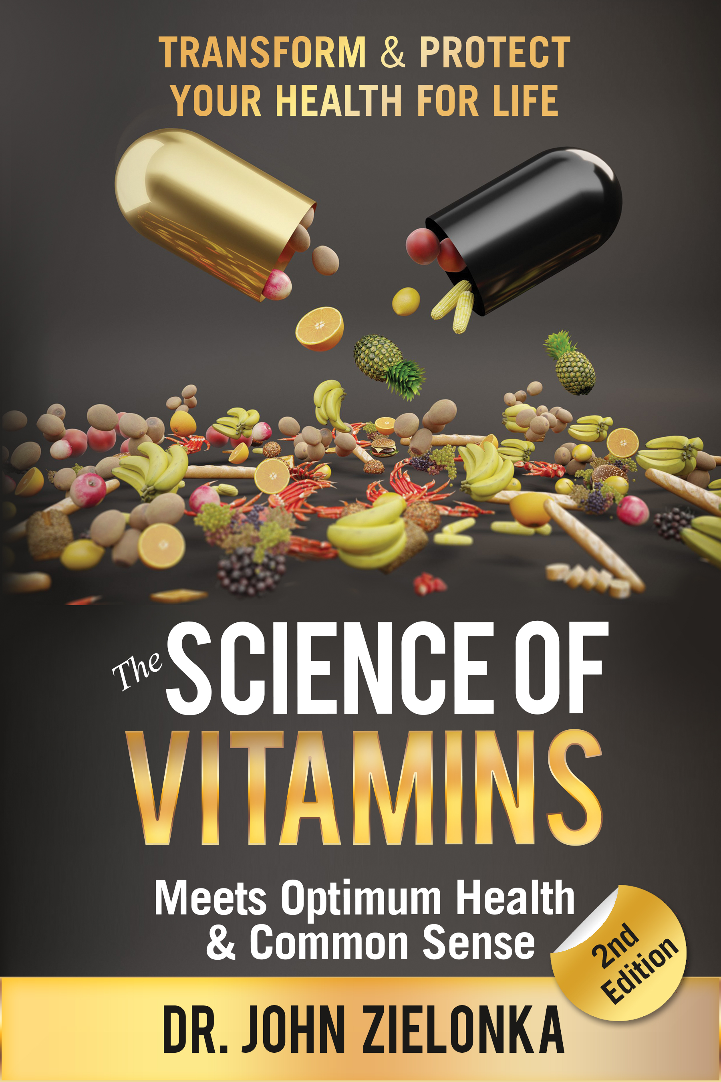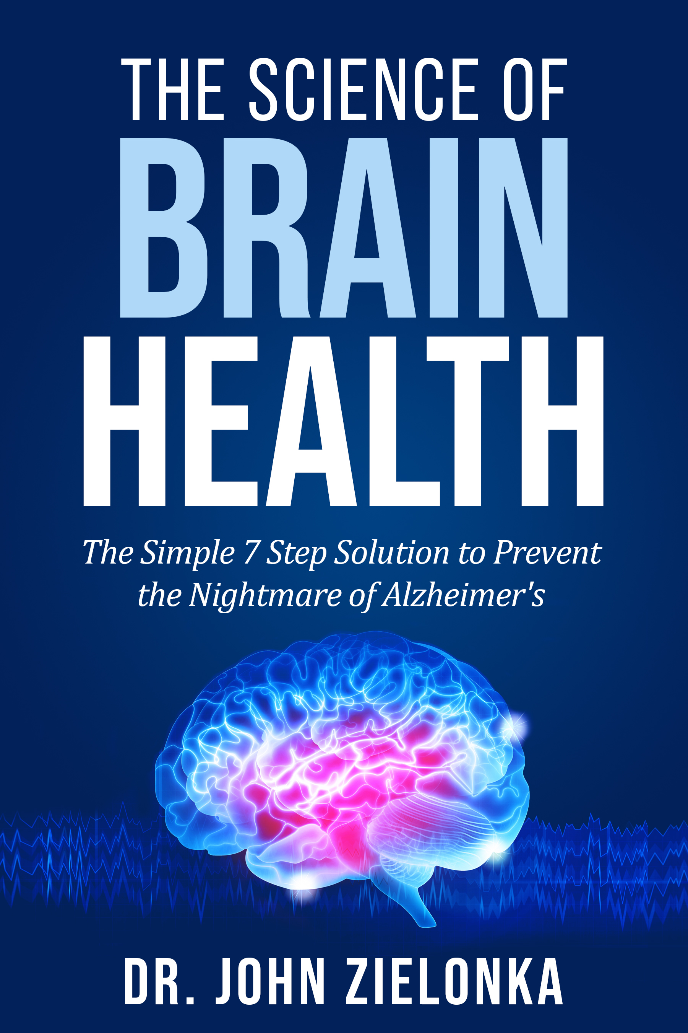
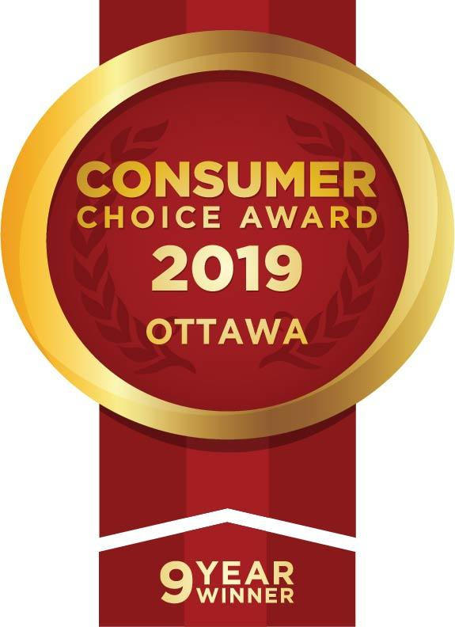

Leadership Trust Integrity Truth Human Health Potential

