Family Health Professionals
New Patient History File # ________

The completion of this form is a sensible first step prior to experiencing the many benefits associated with chiropractic. This form has been designed to assist with delivering the most appropriate chiropractic treatment and/or identifying any possible risk factors to your health and safety to provide appropriate care and advice.

Title: Dr / Mr / Mrs / Miss /Ms
GIVEN NAMES:_________________________________SURNAME:______________________________ OCCUPATION: ________________________________________ Date of birth: ______/______/ 19_______ ADDRESS: ___________________________________________________________________________ SUBURB: ______________________________________________ POST CODE: __________________ PHONE: (H) ____________________ (W) ____________________ (M) ________________________ Email: ________________________________________________________________________________ Spouse:___________________________________ Children:____________________________________ Who can we contact in case of an emergency? _______________________________________________ Contact Number:______________________________ Relationship to You:________________________ Medical Doctors Name __________________________________ Contact Number: __________________

How did you hear about us? Yellow Pages________ Google_______ Signage ___________ Staff_____________ Clinic Patient (please provide name so we may thank them) _______________________ Other ____________________

Reason for this visit: ____________________________________________________________________ I am only interested in alleviating my pain Yes____ No____
I am interested in resolving the cause of my problem Yes____ No____
Have you received treatment for this in the past? Yes____ No____
Details of past treatment: _________________________________________________________________

PLEASE INDICATE BY CIRCLING AREAS OF CONCERN OR COMPLAINT ON THE DIAGRAM BELOW
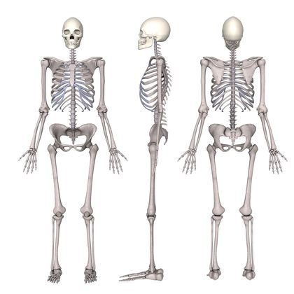
Are you on any medication? (if yes please note below) Y N
Have you had a motor vehicle accident or serious injury? Y N
Have you been admitted to hospital in the past 12 months? Y N
Do you have any xrays, CT scans, MRI, Ultrasound? Y N
Do you have any ongoing health problems? Y N
Have you had any unexplained weight loss? Y N
Have you had any abnormal bleeding from any body part? Y N
Have you had any recent changes in a mole or freckle? Y N
Do you have any unusual lumps or swellings? Y N

If you answered yes to any of the above please supply details here: _______________________________
_____________________________________________________________________________________

Is this a Work Cover or Motor Vehicle accident claim? Y / N
If Yes, When was the date of the accident? ___________ Please state your claim number: _____________
SYSTEMS REVIEW HISTORY

Please circle either Yes or No to the following questions about your general health.
This information will give us a better understanding about your body s overall function.

Headaches Y N Neck pain Y N
Dizziness Y N Neck stiffness Y N
Blurred vision Y N Mid back pain Y N
Ring / buzz in ears Y N Chest pain Y N
Difficulty swallowing Y N Palpitations Y N
Loss of consciousness Y N High blood pressure Y N
Numbness in any body part Y N Low blood pressure Y N
Weakness in any body part Y N Heart trouble Y N
Stroke Y N Difficulty breathing Y N
Depression Y N Low back pain Y N
Nervousness Y N Stomach trouble Y N
Sleeping problems Y N Indigestion Y N
Energy loss Y N Liver problems Y N
Morning tiredness Y N Colon problems Y N
Fainting feeling Y N Diabetes Y N
Sinus problems Y N Kidney / bladder problems Y N
Allergies Y N Poor circulation Y N
Female problems Y N Upper limb problems Y N
Male problems Y N Lower limb problems Y N

Other:_______________________________________________________________________________________________________________________________________________________

Relevant Family History: __________________________________________________________
______________________________________________________________________________

Please note that any and all information, written or otherwise, that you give us is strictly confidential and is so treated by the entire staff. No information or records will be released to any person, health fund, insurance company or any doctor without the written permission of the patient.

We would like to include you on our email list so you receive our health updates and special offers, please check this box if you DO NOT wish to receive these emails.

I believe the information above is correct to the best of my knowledge. (Please sign below)

Cancellations: We ask that you respect our cancellation policy to ensure we have enough time to contact other clients on our waiting list. 24 hours notice is required for cancellation or re-scheduling. If notice is not received, a cancellation fee may be charged.

Patient/s Signature: _____________________________ Date: / /20

