Riverside Chiropractic Health Center
New Patient Intake Form
Today’s Date: ________________
PATIENT INFORMATION:
Full Legal Name: _______________________________Preferred Name:__________________
Birth Date: ___/___/______ Age: ______ Sex ___ Marital Status _____________
Address: ________________________ City: ______________State: ______ Zip Code: ________
Email Address: ________________Home Number: __________Mobile Number: ___________
Social Security #: ______________________ Driver’s License #: __________________________
Employer + Address: __________________Occupation: ______________________
Height:______Weight _______Hobbies _________How did you hear about our office:________
EMERGENCY CONTACT:
Name: ________________Phone Number: ____________Relationship to Patient: ___________
Patient Condition:
Reason(s) or visit: ________________________________________________________________
______________________________________________________________________________
______________________________________________________________________________
Please indicate type and severity of pain/discomfort with the below key on the diagram:
Type of Pain: A=Achy S=Sharp
N=Numb C=Cramps T=Tight
Pain: Scale 0-10
1=Mild 10=Severe

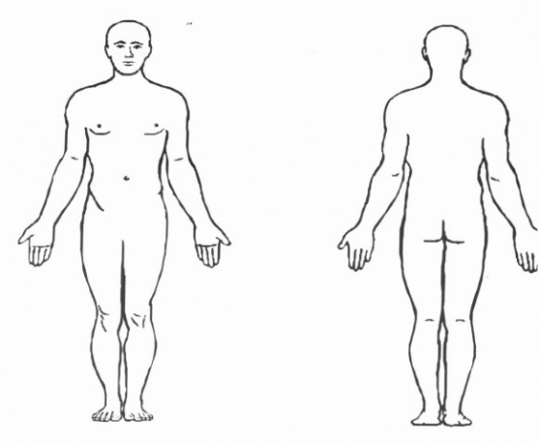

When & how did your symptoms appear? ________________________ ___________________________________________________________
___________________________________________________________
How often do you have this pain/sensation?
☐ 0/25% of the day ☐ 26/50% of the day ☐ 51/75% of the day ☐ 76/100% of the day
Does it interfere with your ☐Work ☐Sleep ☐Daily Routine ☐Recreation ☐ Other________________
Activities or movements that are painful to perform ☐ Sitting ☐ Standing ☐ Walking ☐Bending ☐Lying Down ☐ Other____________________________________________________________
Are you concerend about your posture? Yes ☐ No ☐
HEALTH HISTORY:
What treatment have you already received for your condition? ☐ Chiropractic ☐ Physical Therapy
☐ Massage ☐ Stretching ☐ Acupuncture ☐ Surgery ☐ None ☐ Other ______________________
☐ Medications including Over The Counter (if so what kind and how much):_______________________
☐ Epidural or steroid Injection (if so how many and when):_____________________________________
List all health care professionals seen for this/these issue(s) including type of doctor: (ex. Primary doctor, Orthopedic, podiatrist, emergency room, chiropractors, etc.) ________________________________________________________________________________________________________________________________________________________________________________________________________________________________________________________________________________________________________________________
Please list estimated dates of the following: Physical: _________ Spinal Exam ________
Spinal X-Ray: _______MRI:________________ CT Scan:___________ Bone Scan:___________
Blood Test: ________
List all strains/ sprains/ broken bones, how they happened and estimated dates: _______________________________________________________________________________________________________________________________________________________________________________________________________________________________________________________________
List all hopspitalizations and dates: __________________________________________________________________________________________________________________________________________________________________________
Are you pregnant? Yes☐ No☐ Due Date: _______________
Please list including doseages and how many times a day:
Medications (What & Why) Vitamins/Herbs/Minerals

_____________________________ ______________________________
_____________________________ ______________________________
_____________________________ ______________________________
_____________________________ ______________________________
Work Activity: Habits:
☐ Sitting ☐ Smoking Packs/ Day ___________
☐ Standing ☐ Alcohol Drinks Week___________
☐ Light Labor ☐ Caffeine Drinks Cups/Day ___________
☐ Heavy Labor ☐ High stress Reason____________________

Do you exercise on a regular basis? ☐ Yes ☐ No

If answered yes what kind of excerise do you do?
__________________________________________________________________________________________________________________________________________________________________________________________________________________________________________

Is there anything else you would like Dr.Holstein to know about you
__________________________________________________________________________________________________________________________________________________________________________________________________________________________________________

Patient Signature___________________________ Date_______

Doctor Signature___________________________ Date_______

