PATIENT INFO
Last Name: __________________________ First Name: _____________________
Street: _____________________City: ___________ State:________ Zip: ________
Date of Birth: __________ Home Phone:______________ Mobile Phone: _____________
Gender: Male / Female SSN: _______-______-_______ Marital Status: Yes / No
Email Address: ___________________________________________________

POLICY HOLDER (If Different From Patient)
Last Name: _______________________ First Name: _______________________
Date of Birth: _____________Phone: _______________ SSN: ______-_____-______
Does your plan include any of the following?
□ Health Savings Account (HSA) □ Health Reimbursement Account (HRA) □ Flex Savings Account (FSA)
Is this patient a minor? YES / NO Is this form completed by PATIENT / GARDIAN

AUTO ACCIDENTS Date of MVA: _________________

Attorney: _________________ Phone: ______________ Address: ____________________
Patient Auto INS Name: ______________ Phone: ______________ Fax: _____________
Address: _______________________ Adjuster: _________________ Med Pay: Yes or No
At Fault INS Name: _____________ Phone: ______________ Fax: ________________
Address: _______________________ Adjuster: ____________ Claim #: _______________

WORK COMP. Date of Injury: ________________
Employer: ________________ WC Company: _______________ Claim #: ____________
WC Phone: ____________________ Adjuster: ______________________

Whom may we thank for referring you? _______________________________________

Provider: ______________________
Day 1 Appt: ____________________ Day 2 Appt: _____________________
CURRENT MEDICATIONS □ None
Name: ____________________________ Name: __________________________
Dosage: ____________________________ Dosage: __________________________
Start Date: ____________________________ Start Date: __________________________
Obtained: □ OTC □ Prescription Obtained: □ OTC □ Prescription
Purpose: ____________________________ Purpose: __________________________
ALLERGIES □ No Known Allergies
Name / Type: ________________________________________________________________
Medication Related: □ Yes □ No
Symptom(s): ________________________________________________________________
Comments: ________________________________________________________________
Name / Type: ________________________________________________________________
Medication Related: □ Yes □ No
Symptom(s): ________________________________________________________________
Comments: ________________________________________________________________
PERSONAL MEDICAL HISTORY
Illnesses
Illness: ___________________________ Illness: _____________________________
Start Date: ___________________________ Start Date: _____________________________
End Date: ___________________________ End Date: _____________________________
Surgeries
Surgery: _____________________________ Surgery: _____________________________
Date: _____________________________ Date: _____________________________
Hospitalizations
Reason: _____________________________ Reason: _____________________________
Date: _____________________________ Date: _____________________________
Duration: _____________________________ Duration: _____________________________
Injuries
Injury: _____________________________ Injury: _____________________________
Date: _____________________________ Date: _____________________________
FAMILY MEDICAL HISTORY
Illnesses
Illness: _____________________________ Illness: ___________________________
Relation: _____________________________ Relation: ___________________________
Age of Onset: _____________________________ Age of Onset: ___________________________

REVIEW OF BODY SYSTEMS
Musculoskeletal □ No Issues
Osteoporosis: □ Have □ Had □ No Arthritis: □ Have □ Had □ No
Scoliosis: □ Have □ Had □ No Neck Pain: □ Have □ Had □ No
Back Problems: □ Have □ Had □ No Hip Disorders: □ Have □ Had □ No
Knee Injuries: □ Have □ Had □ No Foot/Ankle Pain: □ Have □ Had □ No
Shoulder Problem: □ Have □ Had □ No Elbow/Wrist Pain: □ Have □ Had □ No
TMJ Issues: □ Have □ Had □ No Poor Posture: □ Have □ Had □ No
Neurological □ No Issues
Anxiety: □ Have □ Had □ No Depression: □ Have □ Had □ No
Headaches: □ Have □ Had □ No Dizziness: □ Have □ Had □ No
Pins & Needles: □ Have □ Had □ No Numbness: □ Have □ Had □ No
Cardiovascular □ No Issues
High Blood Pressure: □ Have □ Had □ No Low Blood Pressure: □ Have □ Had □ No
High Cholesterol: □ Have □ Had □ No Poor Circulation: □ Have □ Had □ No
Angina: □ Have □ Had □ No Excessive Bruising: □ Have □ Had □ No
Respiratory □ No Issues
Asthma: □ Have □ Had □ No Apnea: □ Have □ Had □ No
Emphysema: □ Have □ Had □ No Hay Fever: □ Have □ Had □ No
Shortness of Breath: □ Have □ Had □ No Pneumonia: □ Have □ Had □ No
Digestive □ No Issues
Anorexia / Bulimia: □ Have □ Had □ No Ulcer: □ Have □ Had □ No
Food Sensitivities: □ Have □ Had □ No Heartburn: □ Have □ Had □ No
Constipation: □ Have □ Had □ No Diarrhea: □ Have □ Had □ No
Sensory □ No Issues
Blurred Vision: □ Have □ Had □ No Ringing in Ears: □ Have □ Had □ No
Hearing Loss: □ Have □ Had □ No Chronic Ear Infection: □ Have □ Had □ No
Loss of Smell: □ Have □ Had □ No Loss of Taste: □ Have □ Had □ No
Integumentary □ No Issues
Skin Cancer: □ Have □ Had □ No Psoriasis: □ Have □ Had □ No
Eczema: □ Have □ Had □ No Acne: □ Have □ Had □ No
Hair Loss: □ Have □ Had □ No Rash: □ Have □ Had □ No
Endocrine □ No Issues
Thyroid Issues: □ Have □ Had □ No Immune Disorders: □ Have □ Had □ No
Hypoglycemia: □ Have □ Had □ No Frequent Infection: □ Have □ Had □ No
Swollen Glands: □ Have □ Had □ No Low Energy: □ Have □ Had □ No
Genitourinary □ No Issues
Kidney Stones: □ Have □ Had □ No Infertility: □ Have □ Had □ No
Bedwetting: □ Have □ Had □ No Prostate Issues: □ Have □ Had □ No
Erectile Dysfunction: □ Have □ Had □ No PMS Symptoms: □ Have □ Had □ No
Constitutional □ No Issues
Fainting: □ Have □ Had □ No Low Libido: □ Have □ Had □ No
Poor Appetite: □ Have □ Had □ No Fatigue: □ Have □ Had □ No
Sudden Weight Gain/Loss: □ Have □ Had □ No Weakness: □ Have □ Had □ No
ASSIGNMENT OF HEALTH PLAN BENEFITS AND RIGHTS
AS WELL AS AN
APPOINTMENT AND/OR DESIGNATION AS MY PERSONAL REPRESENTATIVE AND AN ERISA/PPACA REPRESENTATIVE AND BENEFICIARY

I understand and agree that (regardless of whatever health insurance or medical benefits I have), I am ultimately responsible to pay City Health Services; Renaissance Health Services, LLC, Fiesta Health Services, LLC, as well as all employees, employers, representatives, and agents thereof, (hereinafter collectively referred to as “Healthcare Provider”) the balance due on my account for any professional services rendered and for any supplies, tests, or medications provided.
I hereby authorize payment of, and assign my rights to, any health insurance or medical plan benefits directly to Healthcare Provider for any and all medical/healthcare services, supplies, tests, treatments, and/or medications that have been or will be rendered or provided; as well as designating and appointing Healthcare Provider as my beneficiary under all health insurance or medical plans which I may have benefits under.
I hereby authorize the release of any health status, conditions, symptoms or treatment information contained in your records that is needed to file and process insurance or medical plan claims, to pursue appeals on any denied or partially paid claims, for legal pursuit as to any unpaid or partially paid claims, or to pursue any other remedies necessary in connection with same.
I hereby assign directly to Healthcare Provider all rights to payment, benefits, and all other legal rights under, or pursuant to, any health plan (including, but not limited to, any ERISA governed plan/insurance contract, PPACA governed plan/insurance contract) rights that I (or my child, spouse, or dependent) may have under my/our applicable health plan(s) or health insurance policy(ies). I also hereby appoint and designate that Healthcare Provider can act on my/our behalf, as my/our Personal Representative, ERISA Representative, and PPACA Representative as to any claim determination, to request any relevant claim or plan information from the applicable health plan or insurer, to file and pursue appeals and/or legal action (including in my name and on my behalf) to obtain and/or protect benefits and/or payments that are due (or have been previously paid) to either Healthcare Provider, myself, and/or my family members as a result of services rendered by Healthcare Provider, and to pursue any and all remedies to which I/we may be entitled, including the use of legal action against the health plan, the insurer, or any administrator. I hereby also declare that Healthcare Provider is my/our beneficiary regarding my/our health plan as contemplated by both ERISA and PPACA, and that Healthcare Provider can pursue any and all rights that I/we may have under state and/or federal law regarding my/our health plan.
This assignment, appointment, and designation will remain in effect unless revoked by me in writing. It is my intent that the effective date of this document shall relate back to include all services, supplies, test, treatments, or medications that have been previously provided by Healthcare Provider. A photocopy or scan or this document is to be considered as valid and as enforceable as the original.

Signed this ______ day of _________________, 20 ____.

X____________________________ (SEAL)
(patient signature)

______________________________
(please print patient name)
X______________________________(SEAL)
(signature of Guardian if applicable)
1. Indicate on the drawings below where you have pain/symptoms. (CHIEF COMPLAINT)
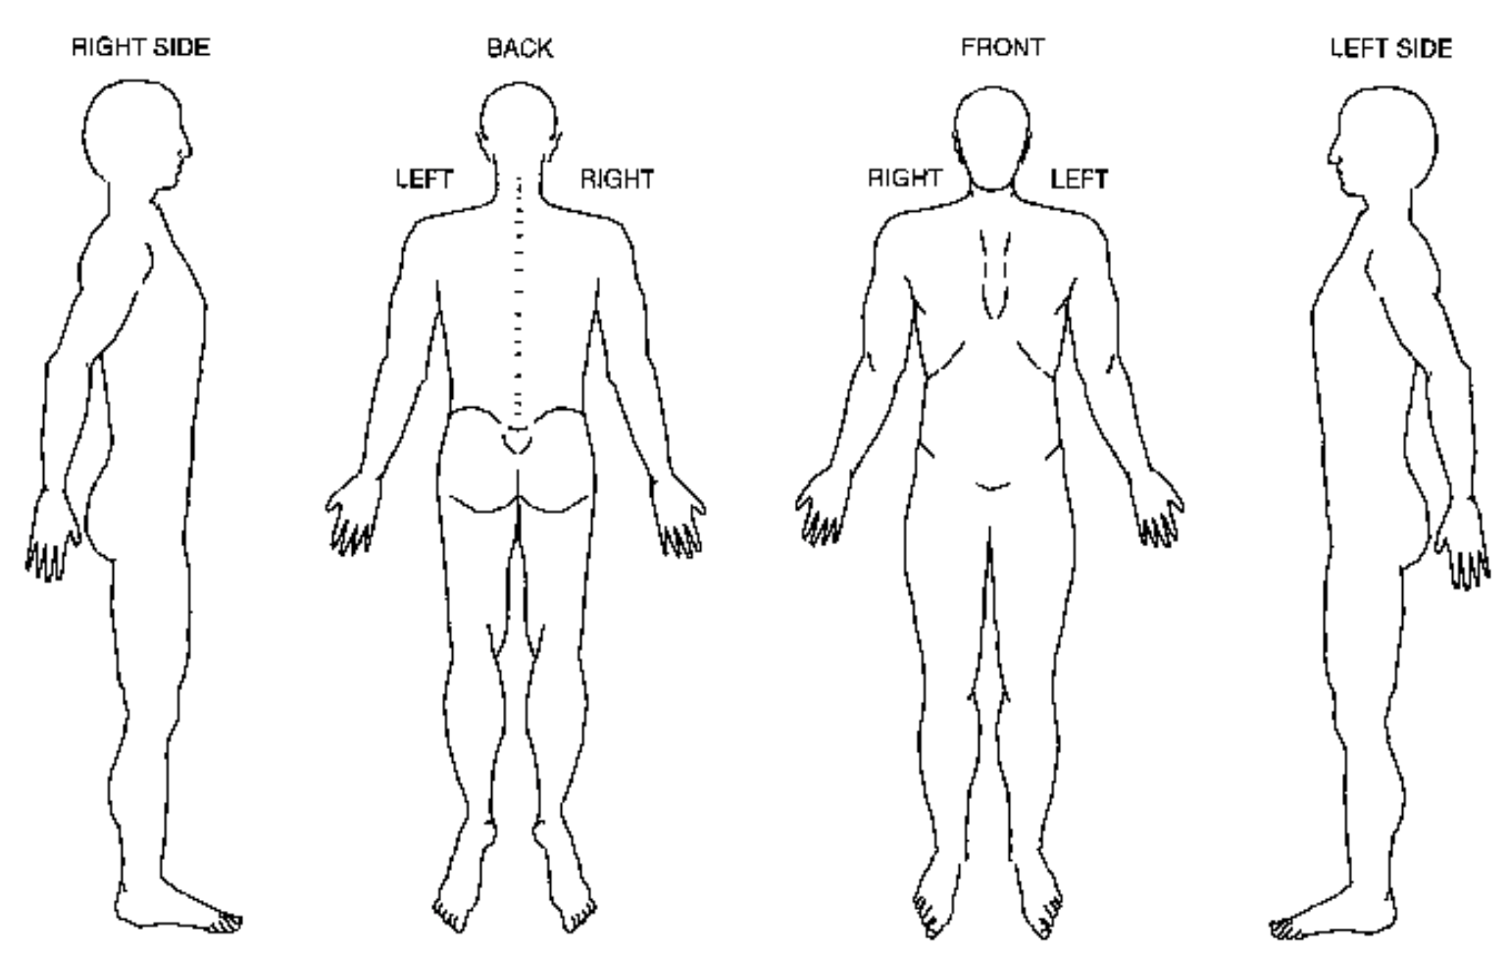
2. Using a scale from 0-10 (10 being the worst), how would you rate your problem? ( AT WORST )
- Headaches □ Migraine
- Arthritis □ Posture
- Neck
- Upper Back
- Low Back
- Shoulder □ Elbow
- Wrist □ Hand
- Hip □ Knee
- Ankle □ Foot
- Sprain / Strain
- Whiplash
- TMJ
- Allergies
- Fibromyalgia
no pain - 0 1 2 3 4 5 6 7 8 9 10 - worst possible pain
3. How do you think the problem began?
□ Unknown □ Over Exertion □ Repetitive Motion □ Recreation □ Exercise
□ House Chores □ Auto Accident □ Work Injury □ Slip Fall □ Surgery
4. When did your problem begin? Date: _______________
5. How often do you experience your symptoms?
□ Intermittently: 1-25% % of the… □ day □ week □ month
□ Occasionally: 26-50% of the… □ day □ week □ month
□ Frequently: 51-75% of the… □ day □ week □ month
□ Constantly: 76-100% of the… □ day □ week □ month
6. How are your symptoms changing with time?
□ Getting worse… □ Staying the same □ Getting better…
□ in the morning □ by midday □ at the end of the day
□ at night □ throughout the day □ at night with pain
7. Do your symptoms affect other areas of your body? □ Yes □ No
If yes, to what area does your pain radiate, shoot, or travel? (Choose all that apply)
□ Left □ Right □ Both Sides
□ shoulder □ upper arm □ arm □ arm to hand
□ buttock □ upper leg □ leg □ leg below the knee □ leg to the foot
8. How would you describe the type of pain you are experiencing? (Choose all that apply)
□ Dull □ Sharp □ Throbbing □ Burning □ Deep □ Aching
□ Tingling □ Stabbing □ Cramping □ Numbness □ Radiating □ Stiffness
9. What factors increase your pain or worsen you symptoms? (Choose all that apply)
□ Sitting □ Standing □ Walking □ Bending □ Stooping □ Lifting
□ Sleeping □ Sneezing □ Coughing □ Straining □ Reaching □ Twisting
□ Looking Up □ Looking Down □ Movement □ Rest □ Lying Face Up □ Driving
□ Typing □ Scooping □ House Chores □ Exercise □ Lying Face Down □ Stair Stepping
10. What factors decrease your pain or improve your symptoms? (Choose all that apply)
□ Sitting □ Standing □ Lying □ Knees Bent Up □ Support
□ No Movement □ Movement □ Heat □ Ice □ Analgesic Topical
□ Ibuprofen □ Medication □ Rest □ Stretching/Exercise □ Chiropractic Adjustments

1. Indicate on the drawings below where you have pain/symptoms. (Secondary Complaint)
- Headaches □ Migraine
- Arthritis □ Posture
- Neck
- Upper Back
- Low Back
- Shoulder □ Elbow
- Wrist □ Hand
- Hip □ Knee
- Ankle □ Foot
- Sprain / Strain
- Whiplash
- TMJ
- Allergies
- Fibromyalgia
2. Using a scale from 0-10 (10 being the worst), how would you rate your problem? ( AT WORST )
no pain - 0 1 2 3 4 5 6 7 8 9 10 - worst possible pain
3. How do you think the problem began?
□ Unknown □ Over Exertion □ Repetitive Motion □ Recreation □ Exercise
□ House Chores □ Auto Accident □ Work Injury □ Slip Fall □ Surgery
4. When did your problem begin? Date: _______________
5. How often do you experience your symptoms?
□ Intermittently: 1-25% % of the… □ day □ week □ month
□ Occasionally: 26-50% of the… □ day □ week □ month
□ Frequently: 51-75% of the… □ day □ week □ month
□ Constantly: 76-100% of the… □ day □ week □ month
6. How are your symptoms changing with time?
□ Getting worse… □ Staying the same □ Getting better…
□ in the morning □ by midday □ at the end of the day
□ at night □ throughout the day □ at night with pain
7. Do your symptoms affect other areas of your body? □ Yes □ No
If yes, to what area does your pain radiate, shoot, or travel? (Choose all that apply)
□ Left □ Right □ Both Sides
□ shoulder □ upper arm □ arm □ arm to hand
□ buttock □ upper leg □ leg □ leg below the knee □ leg to the foot
8. How would you describe the type of pain you are experiencing? (Choose all that apply)
□ Dull □ Sharp □ Throbbing □ Burning □ Deep □ Aching
□ Tingling □ Stabbing □ Cramping □ Numbness □ Radiating □ Stiffness
9. What factors increase your pain or worsen you symptoms? (Choose all that apply)
□ Sitting □ Standing □ Walking □ Bending □ Stooping □ Lifting
□ Sleeping □ Sneezing □ Coughing □ Straining □ Reaching □ Twisting
□ Looking Up □ Looking Down □ Movement □ Rest □ Lying Face Up □ Driving
□ Typing □ Scooping □ House Chores □ Exercise □ Lying Face Down □ Stair Stepping
10. What factors decrease your pain or improve your symptoms? (Choose all that apply)
□ Sitting □ Standing □ Lying □ Knees Bent Up □ Support
□ No Movement □ Movement □ Heat □ Ice □ Analgesic Topical
□ Ibuprofen □ Medication □ Rest □ Stretching/Exercise □ Chiropractic Adjustments

