**Is there such a thing as a healthy cake?**

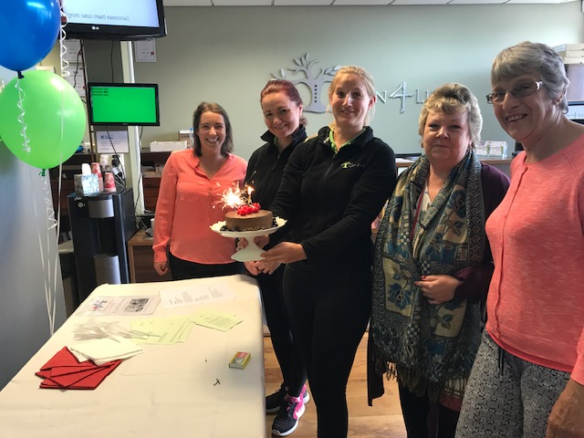

YES!! This Chocolate Mousse Cake, which formed part of our Chiropractic Birthday celebrations, is as healthy as a cake can be (as long you don’t go overboard on the amount you eat!). It tasted great, felt like a real treat and was enjoyed by us all, yet it had no refined sugar, no gluten and no dairy. We had printed a few copies of the recipe in case anyone wanted it and we ended giving it out to nearly everyone who tasted it.

So for those of you who couldn’t make it into the clinic yesterday here is the recipe:

Base Ingredients:

1 x cup of almonds (or any mixture of nuts)

1 x cup of desiccated coconut

1 x cup soaked dates

In a food processor blitz the nuts and coconut to a crunchy texture

Add the dates and process until the mixture comes together.

Press the mixture into the base of a greased 8inch round tin (preferable springform so it is easy to get out!). Place in the fridge while you make the topping.

Mousse Filling:

3 x ripe avocados

1/3 cup agave

½ cup of raw cacao powder

2/3 cup coconut oil

1 x cup pitted soaked dates

½ cup soaked date water

1 tsp vanilla extract

Process avocados, agave, dates and water to a smooth mousse paste.

Add cacao powder and vanilla and process until mixed in.

Add the melted coconut oil and process until combined.

Pour the mousse over the base and place in fridge to set.

Top with your favourite fruit

ENJOY!!