Chiropractic Birthday!

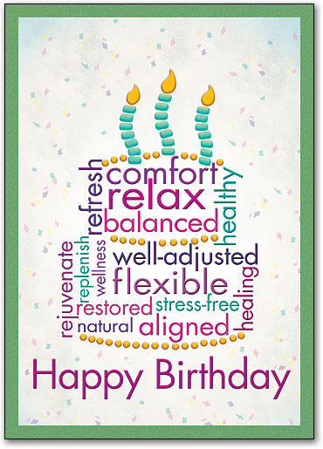
Monday 18th September is the 122nd anniversary of the 1st chiropractic adjustment, something that we at Align 4 Life think is definitely worth celebrating! It is also a good time to reflect on why this drug free health care has endured for so long and continues to grow:

It’s Effective. Because the nervous system controls your entire body, and chiropractic care helps restore nervous system integrity, chiropractic care has been known to help a variety of health issues (including hearing loss which was the reason for the 1st adjustment).

It’s Natural. Simply put, chiropractic care doesn’t add chemicals to your body and it doesn’t remove parts either. Instead, it seeks to restore proper control and regulation of your body so health can return, naturally.

It’s Safe. Chiropractic care is so safe that even newborns can be adjusted to correct any spinal trauma from the birth process!

The only side effects are good ones. Such as better balance, more energy, increased vitality and improved coordination.

It’s the wise choice. It makes sense to correct the underlying cause rather than fool the body with drugs.

If you want to know more about it, why not give us a call on 629444 to book a place at one of our free presentations held 3 times a month. The next one next one is on Tuesday 26 September at 7pm. We look forward to seeing you!

